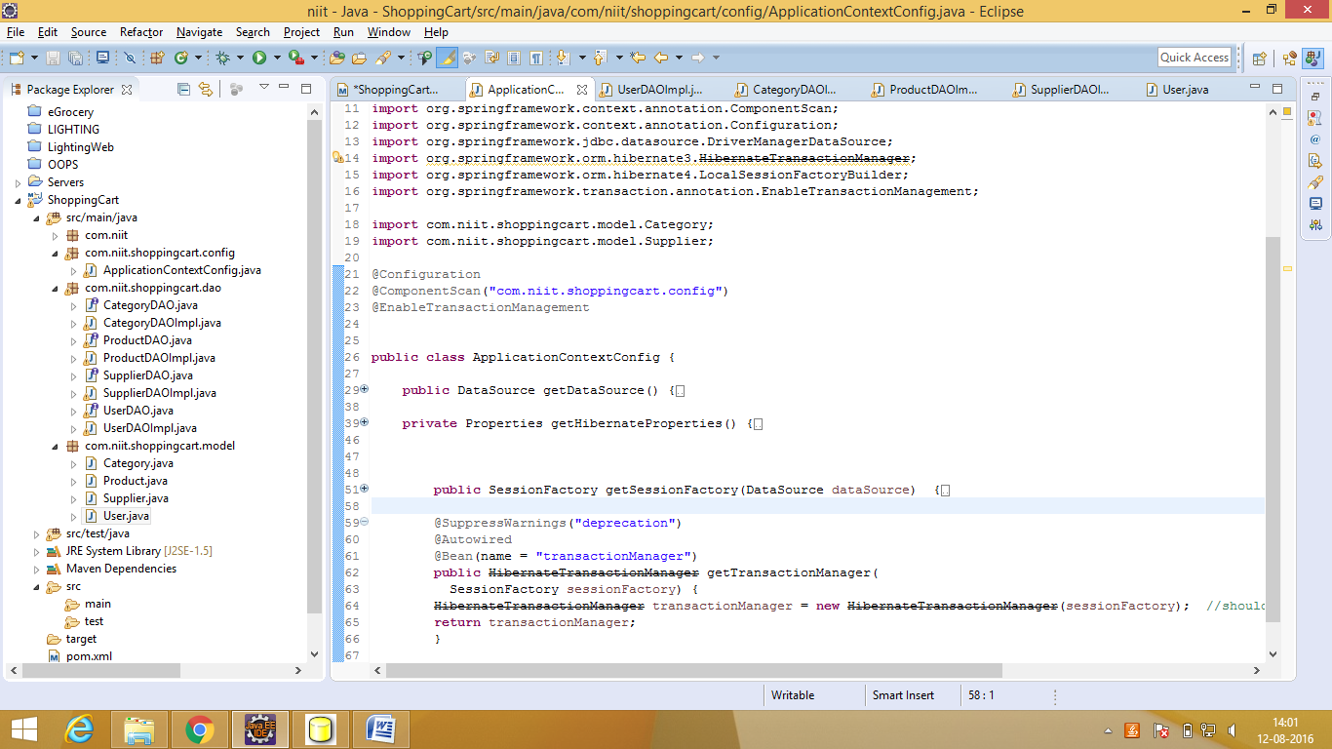

Both the hibernate class shld be same

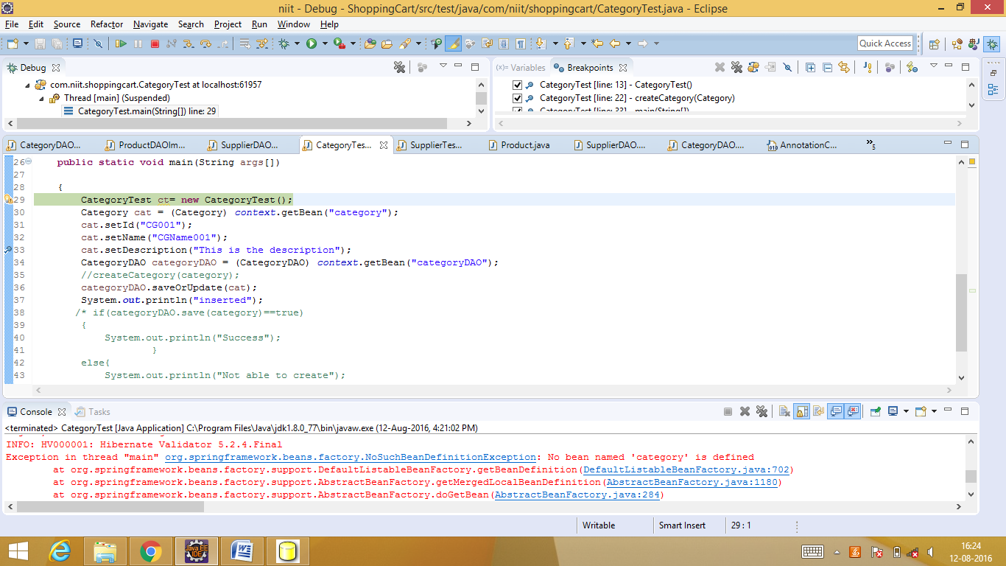

Add category bean to application context similar to categoryDAO bean and

Remove properties.put("hibernate.current_session_context_class","thread");

<http://www.codesenior.com/en/tutorial/orghibernateHibernateException-createQuery-is-not-valid-without-active-transaction>

for hibernate4 it is required

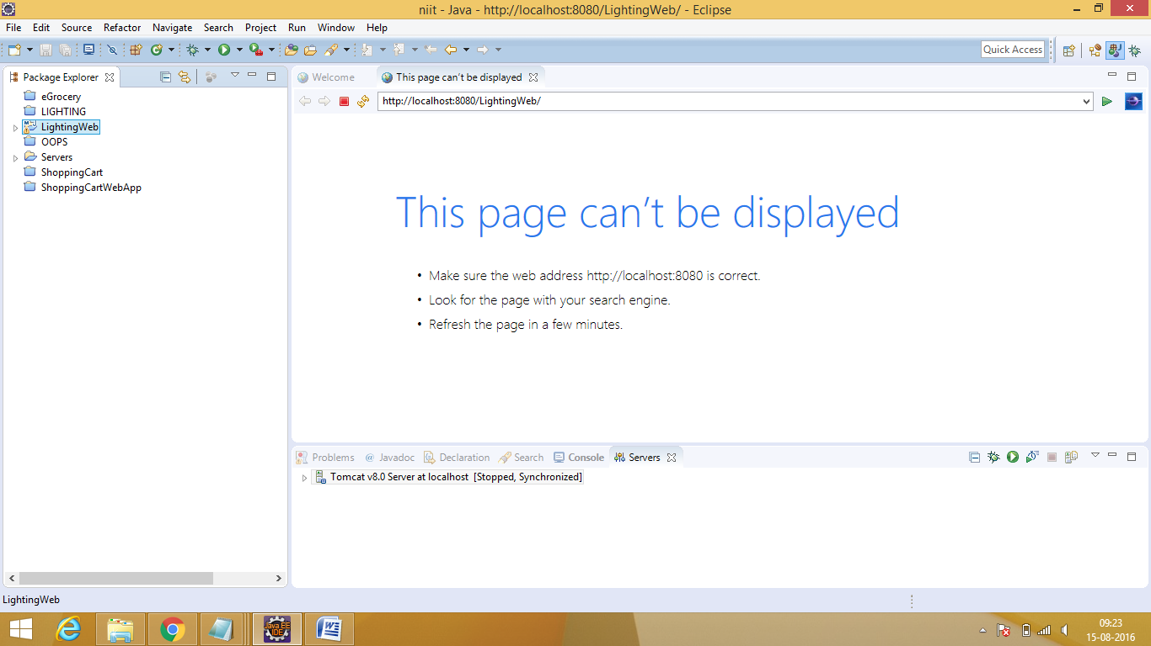

Tomcat error - Before we going to start our project we need to do some set of setups:

1)right ->click on your project -> select properties->go to java compiler

1. Select -> java compiler -> select jdk compliance ->1.8 version->click on apply button
2. Select -> java Build Path->libraries->select jresystemlibrary[j2se1.5] by default jre will be1.5

We need to click on Edit button-> select execution environments jre 1.8 and

Click ok button

9)select down installed jres-> should be jdk1.8

Select jre-> edit -> select a location where you have jdk1.8 location -> then select apply button

And click ok button -> then click on finish button -> then click on apply button

Go to->project facets->> select java 1.8 version and right side runtime -> apache tomcat location

Apache location:

Select apache tomcat where you installed / extracted:

And click on finish button

**OR**

1.WINDOWS->preferences->java->installed jres->add->std vm->find jre home(C:\jdk...)

Select jdk->apply

2. server->runtime envt.

3.build path->add libraries->apache location

* hibernate mapping error:

make the hibernate exception in impl class to exception

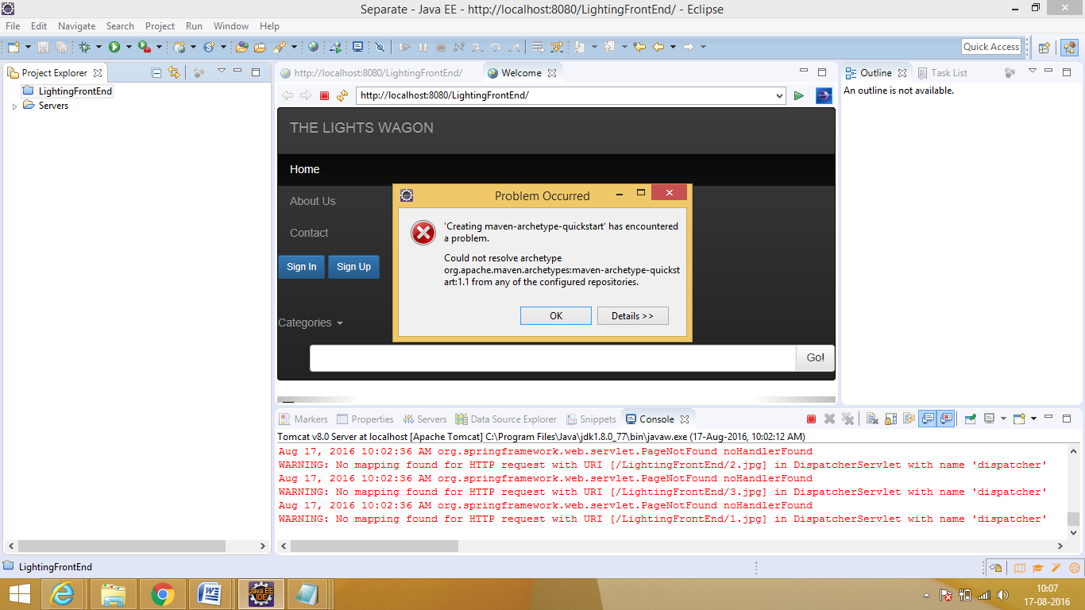

Create project frm cmd prompt

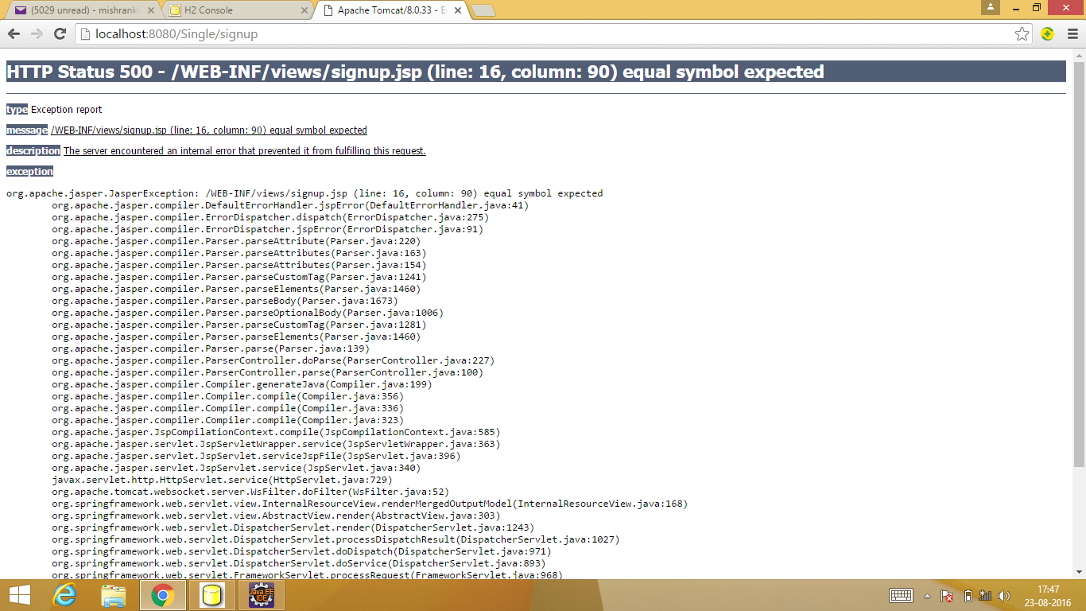

Input type= missing

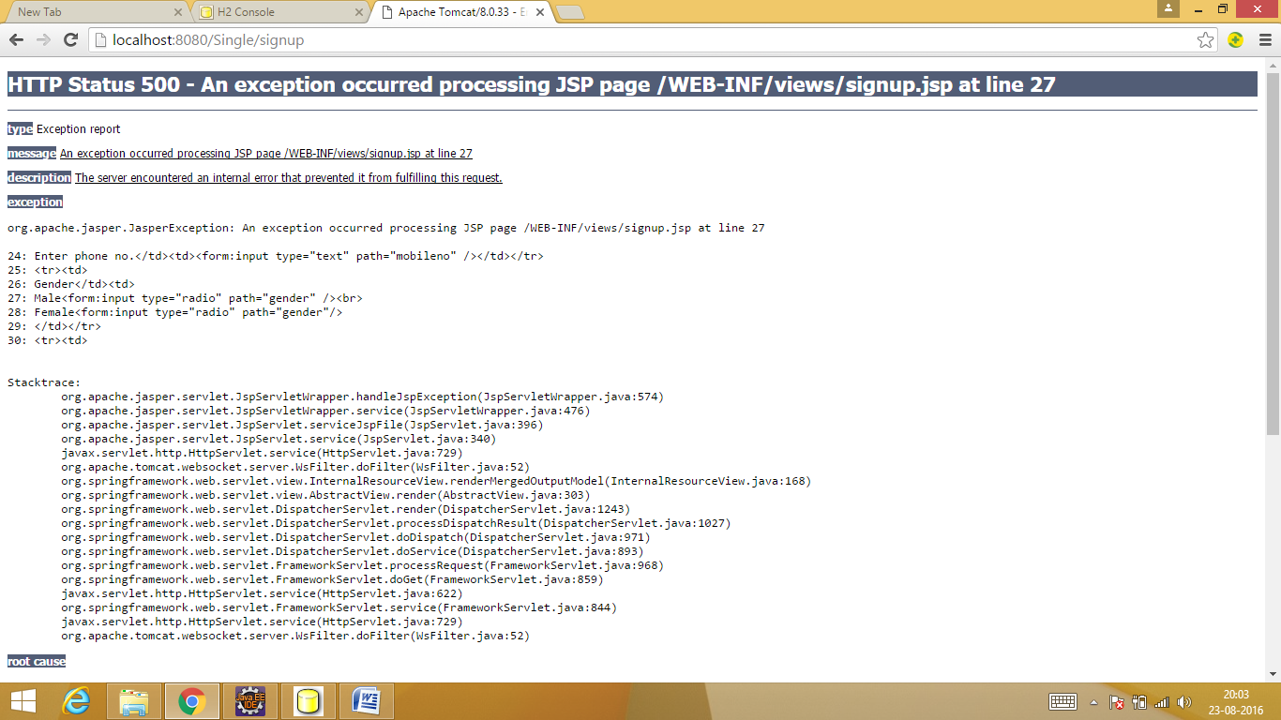

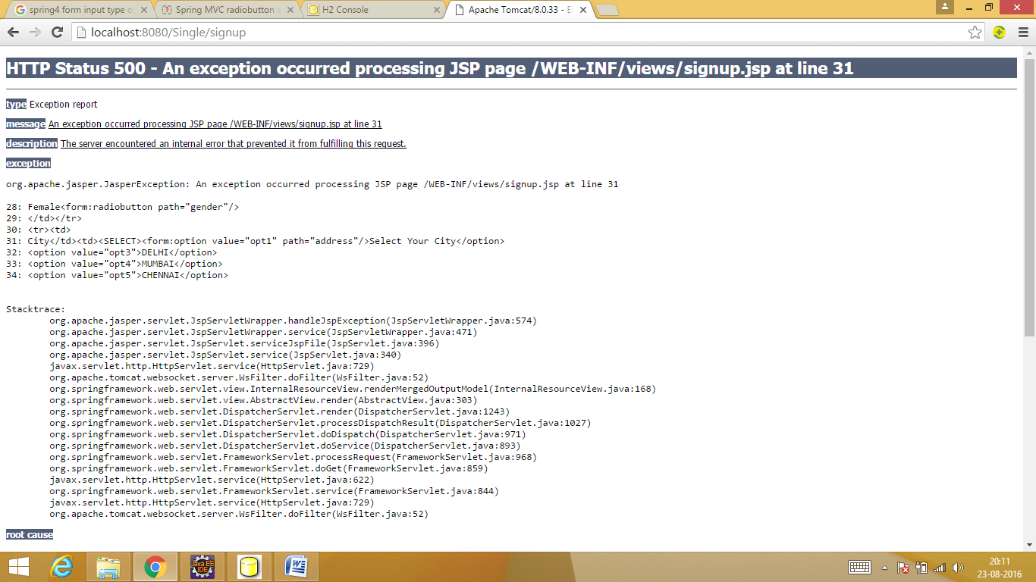

Option dropdown cant be done as normal html pg

25/08/2016

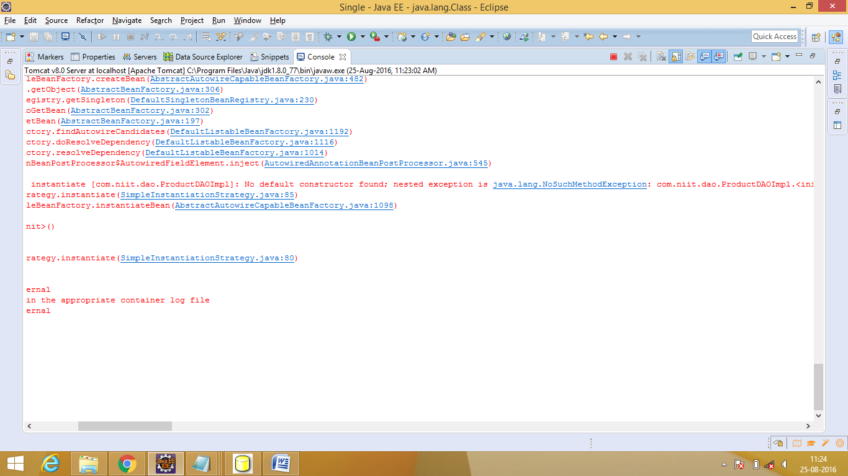

Clean tomcat(stop and start) and add spring-tx jar

27/08/2016

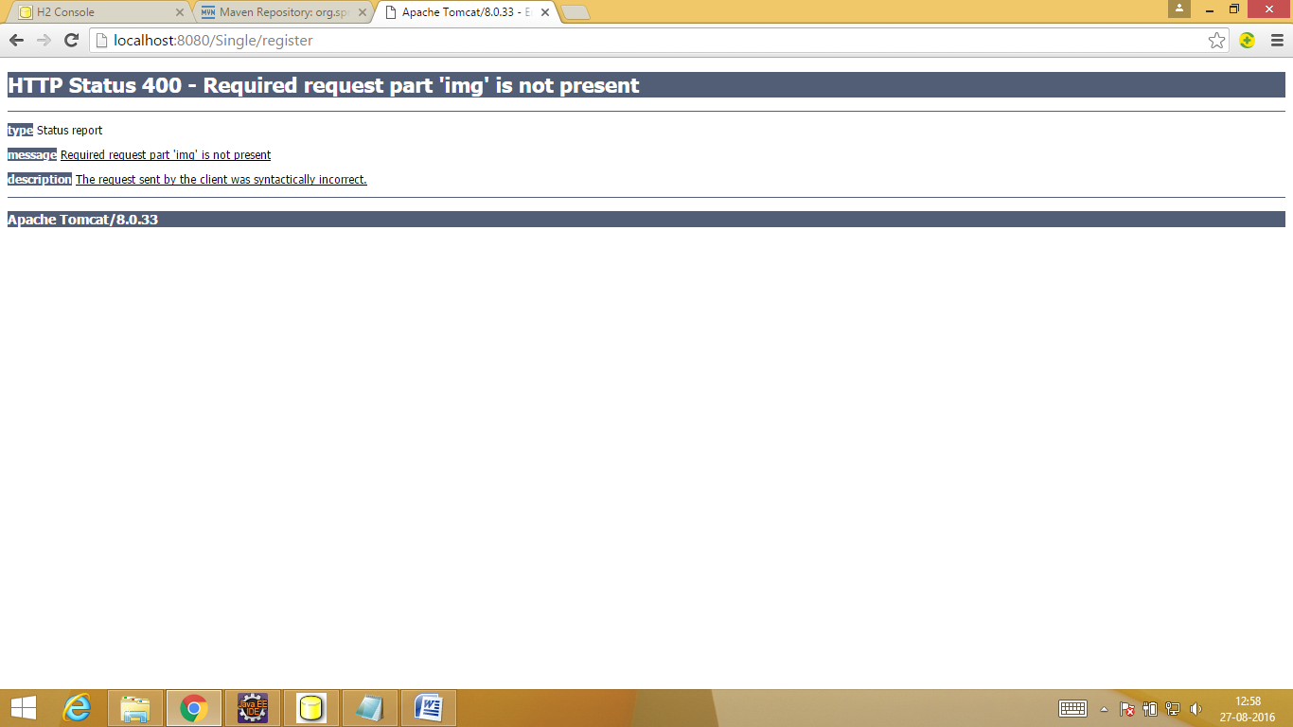

Img should be ‘image’=the name which is given in product.java

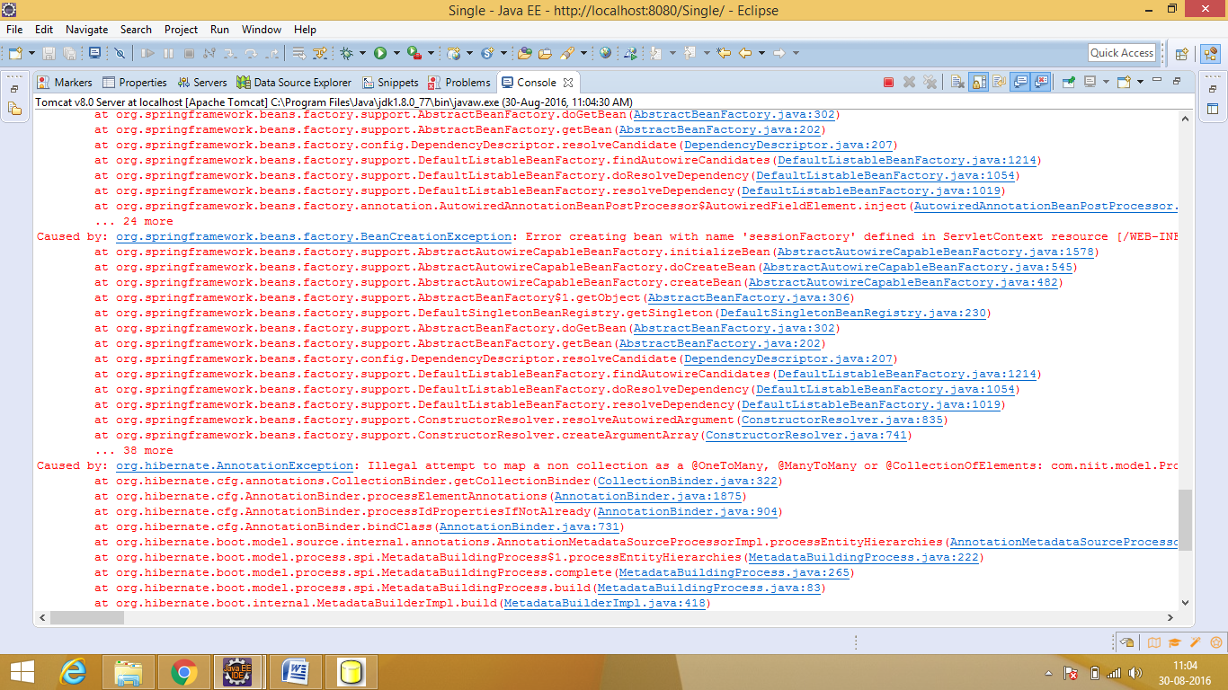

Need to create target class as hash set

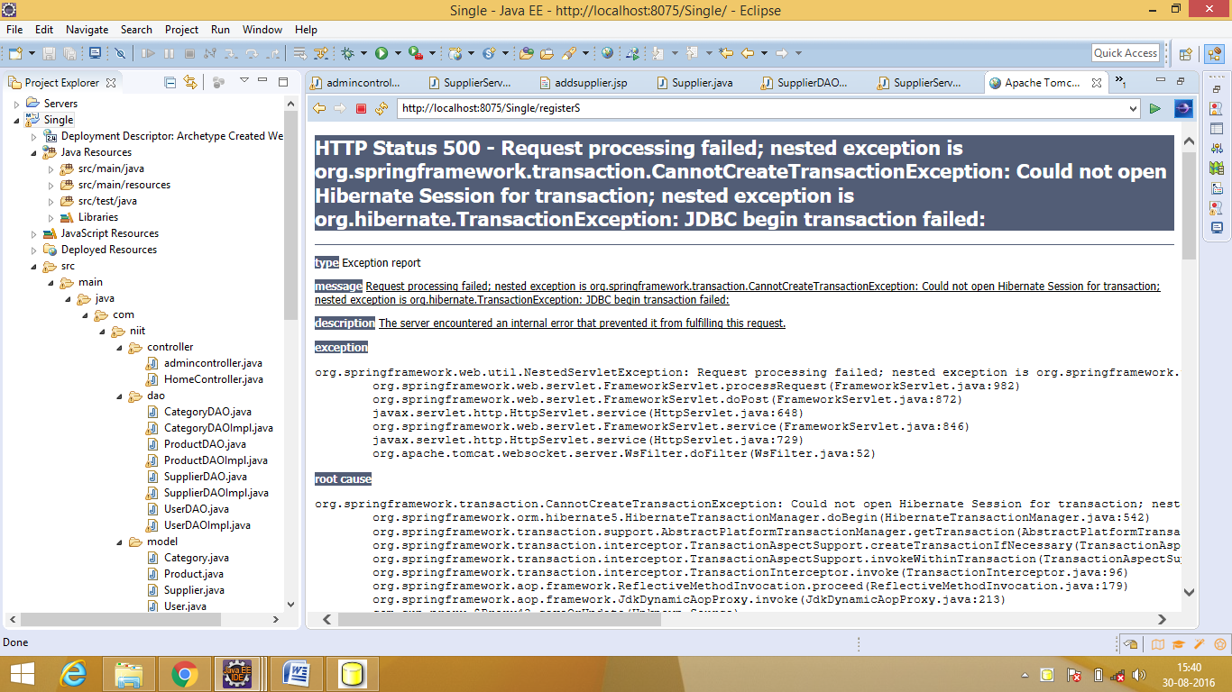

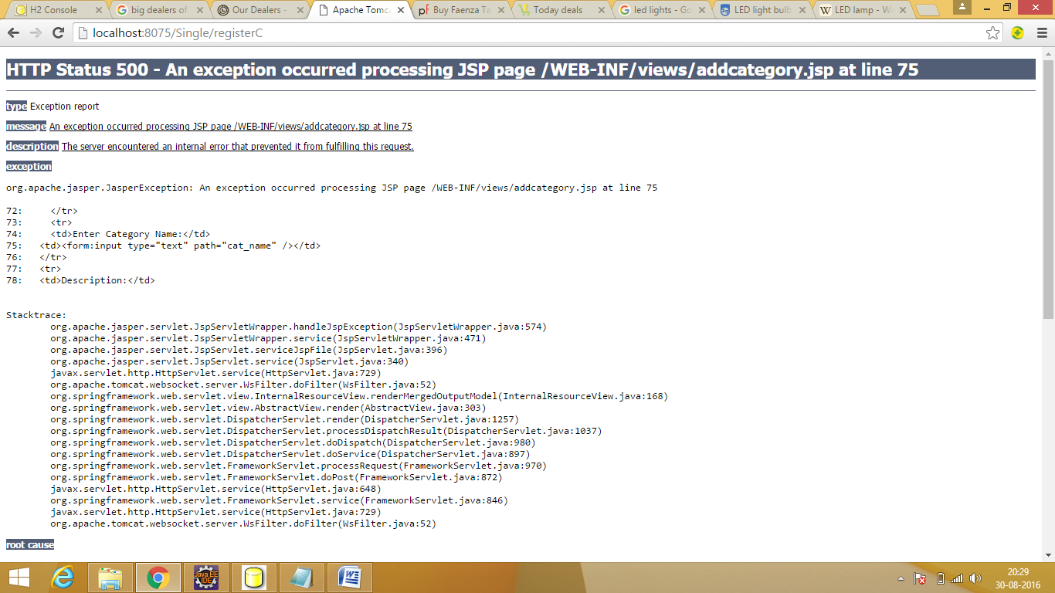

Bindingresult was missing in controller

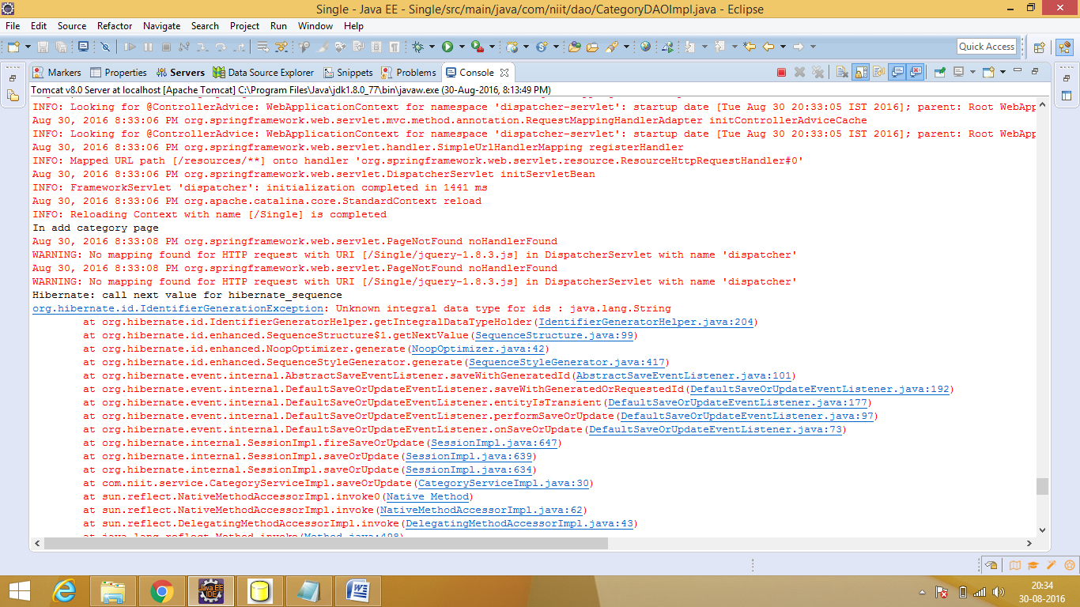

Datatype was string ...changed to int

1/09/2016

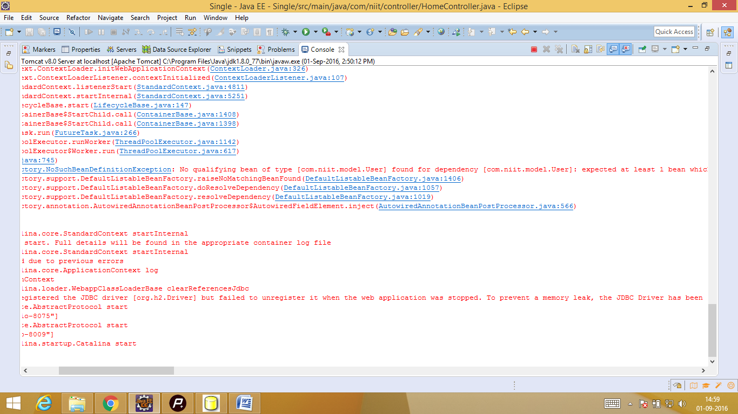

BindingResult missing

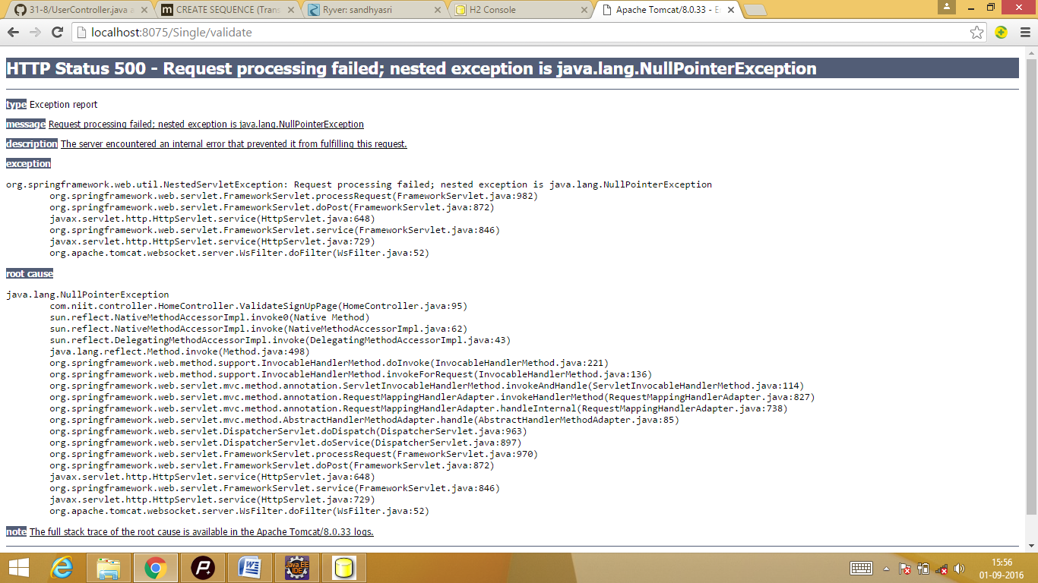

S.O.P was put at the wrong place

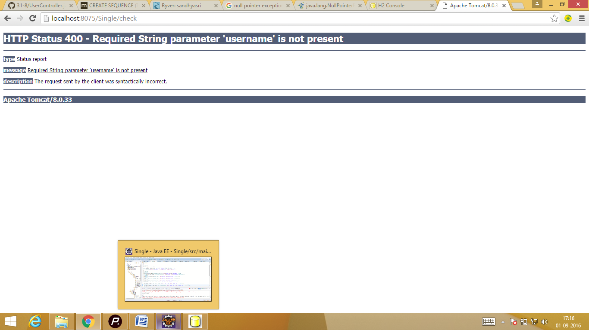

Value=’was given wrong’..it should be the value of the name in form

3/9/16

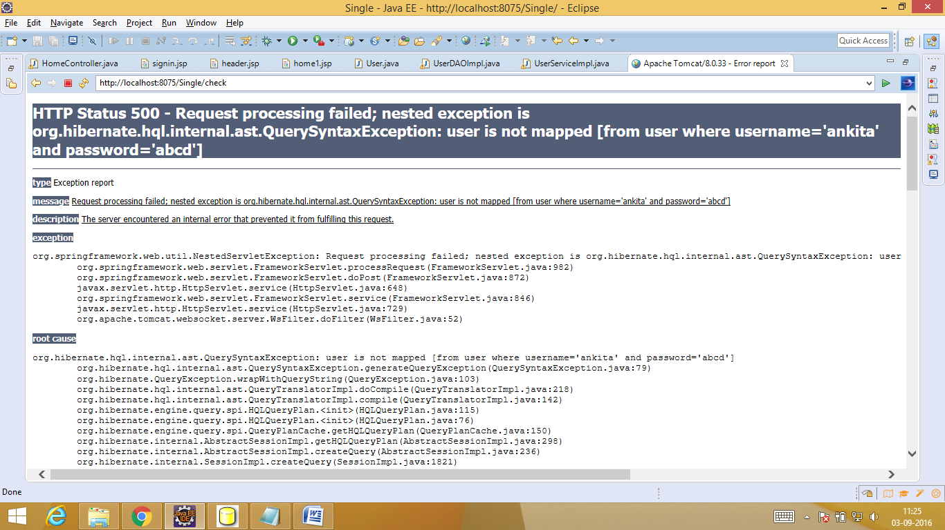

Table name should be User and not user

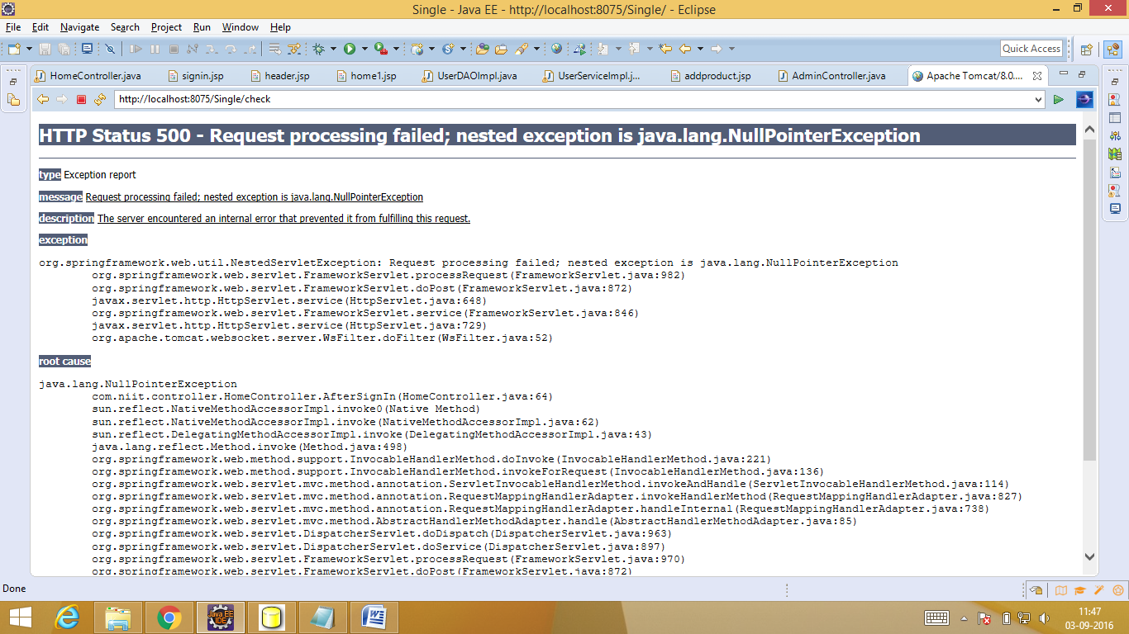

This was because of using S.O.P for null values

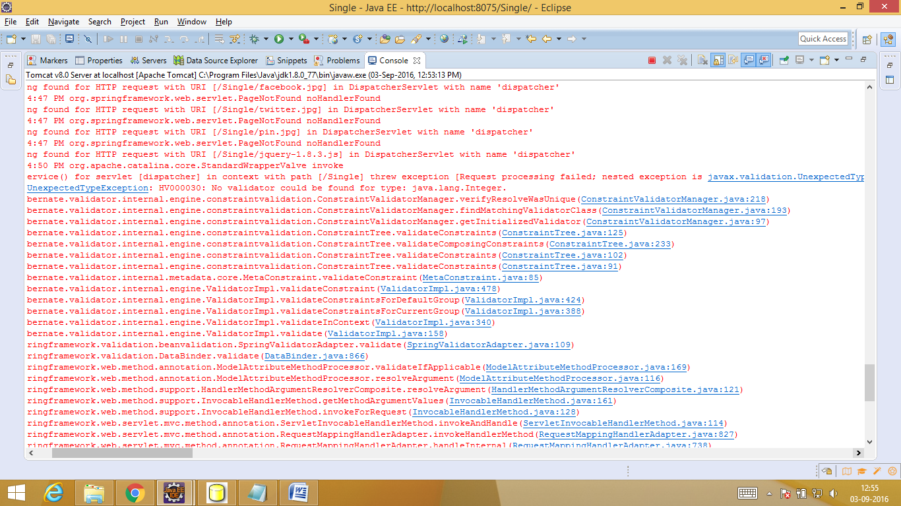

Constraint should be NotNull and not NotEmpty

5/9/16

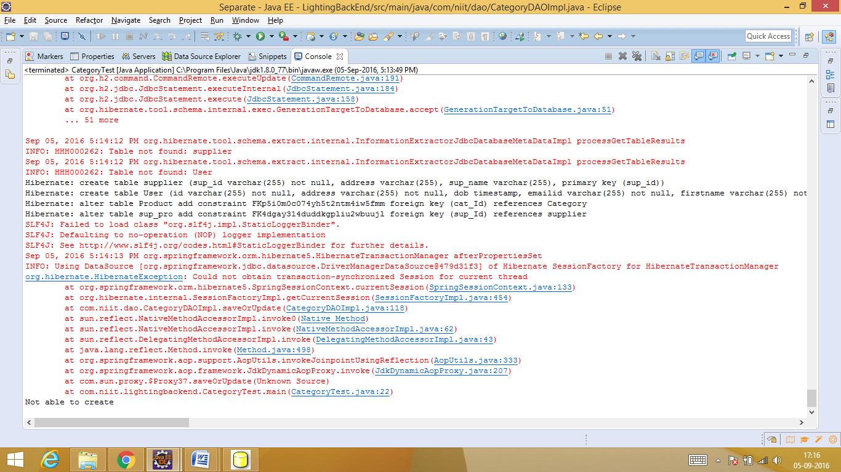

@Transactional was missing

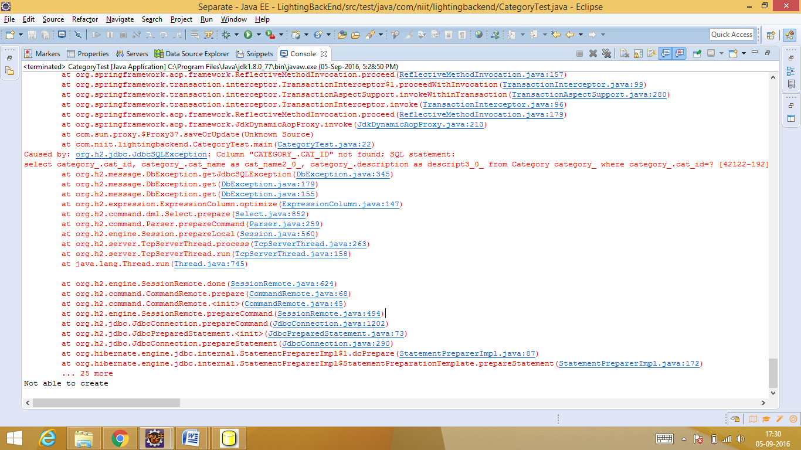

Column name was not matching

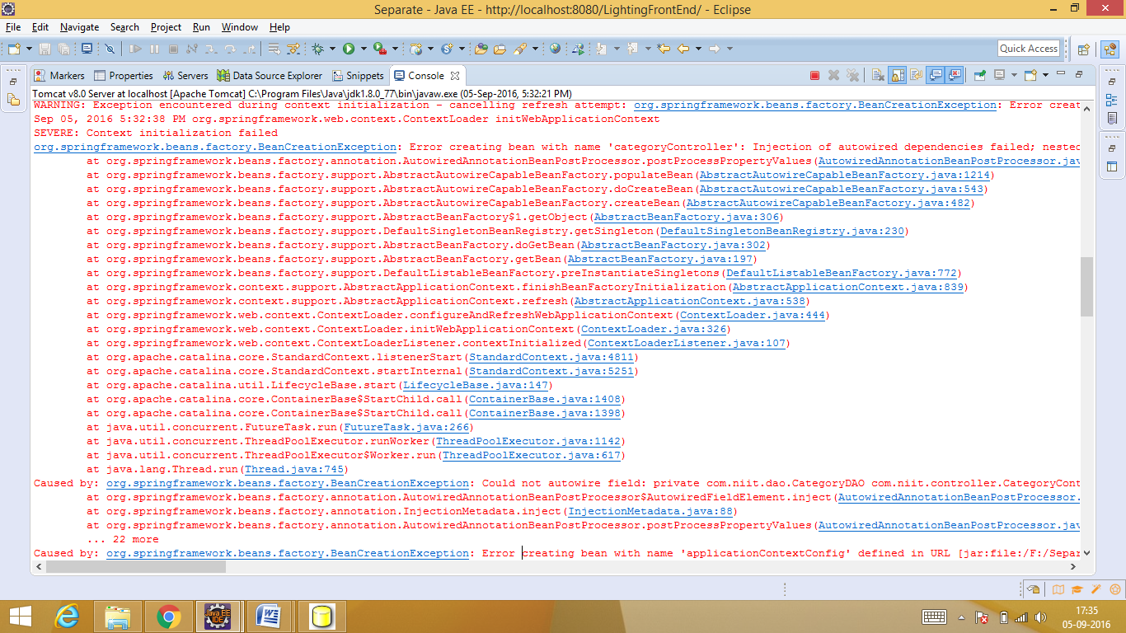

Category c1 was already created in add category so may be it was clashing when category was again autowired above..so category object was created inside update function

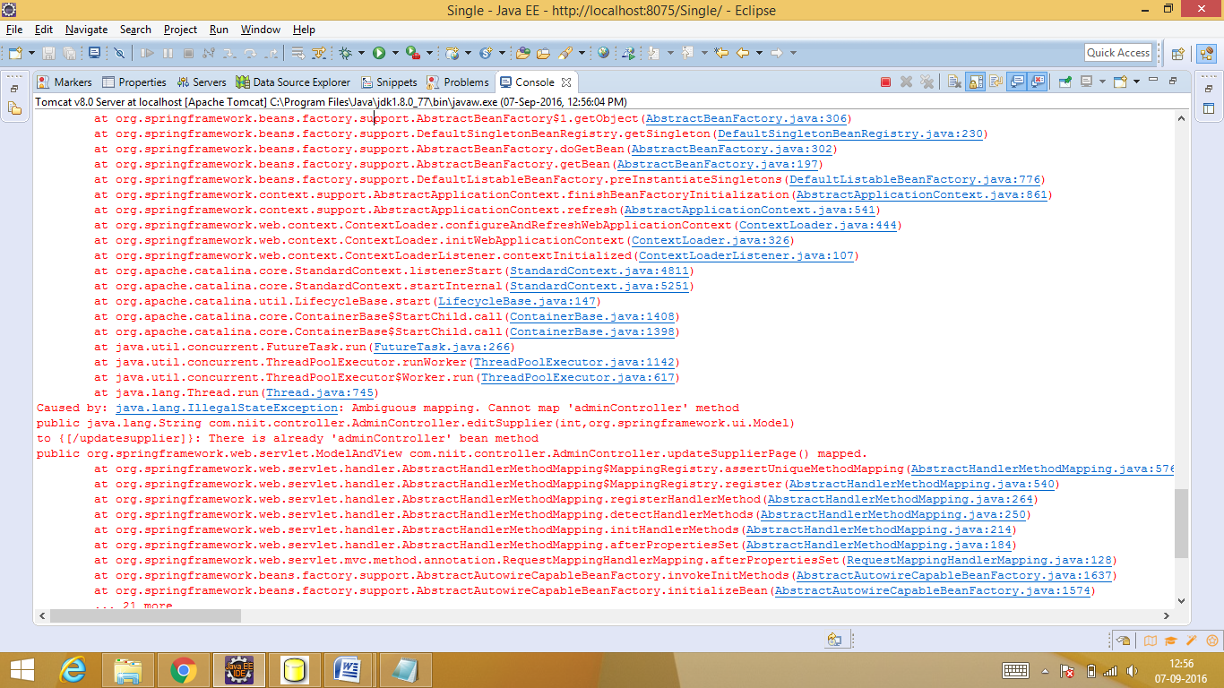

Updatesuppliers requestmapping was called 2 times

7/9/16

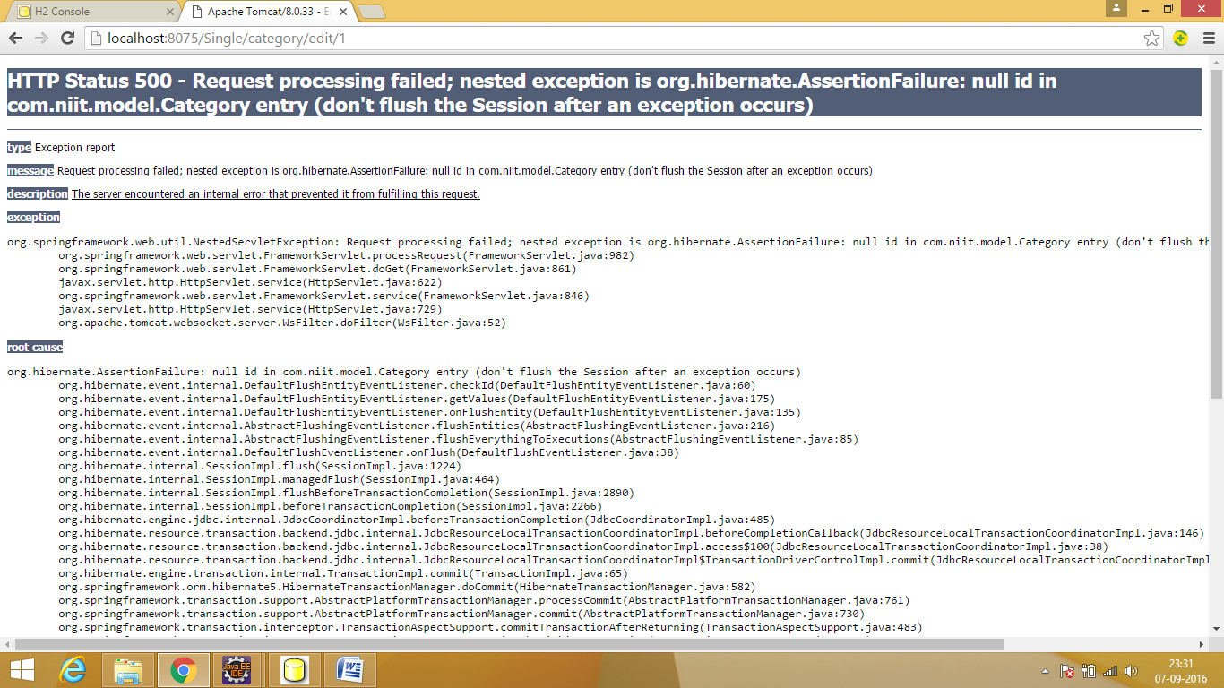

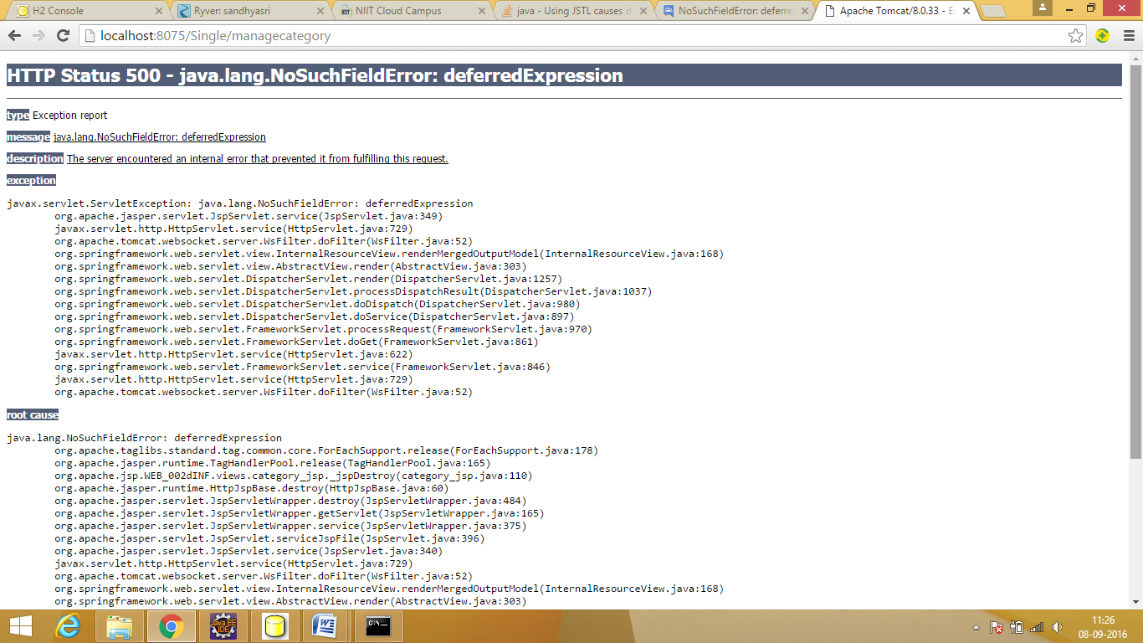

Jstl dependency were added 2 times...javx.servlet jstl was removed

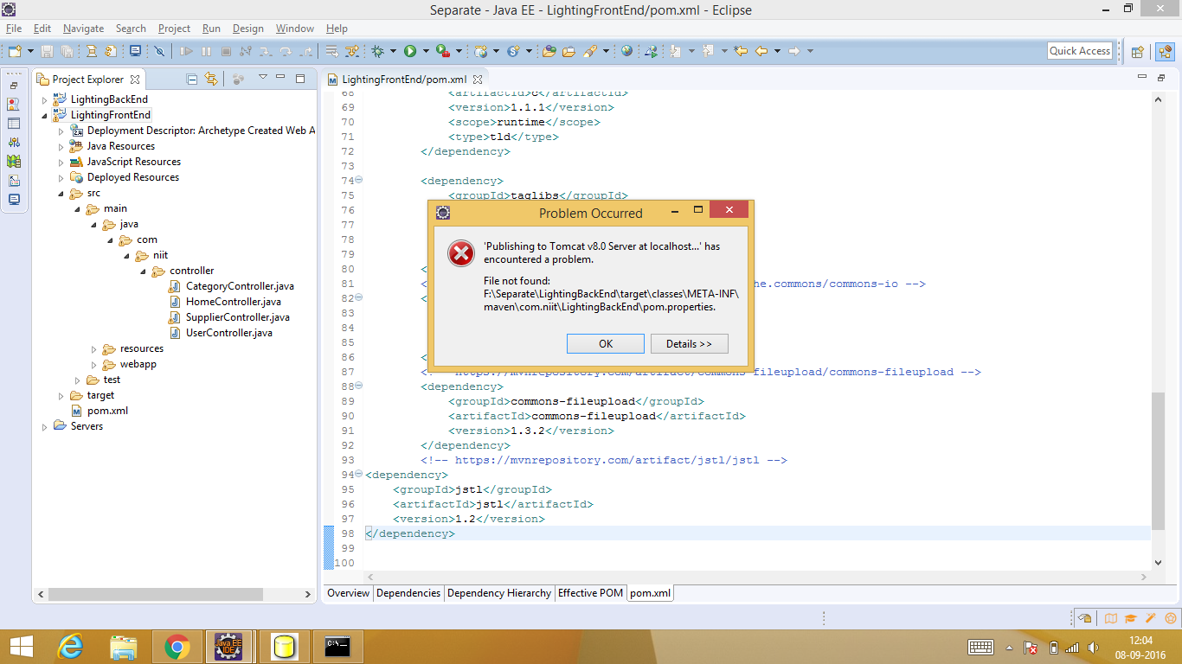

Solved automatically after restarting project

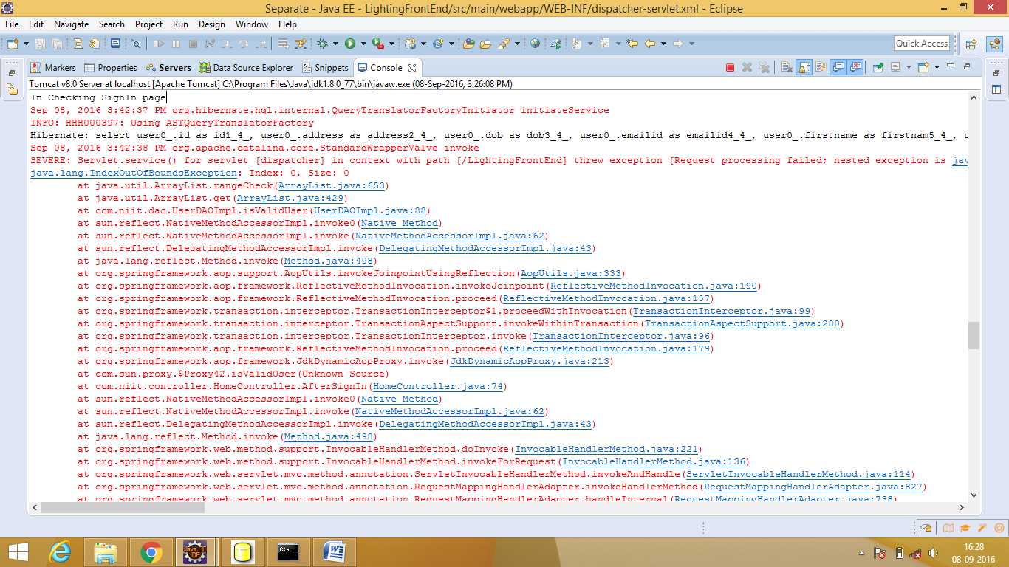

No data in table

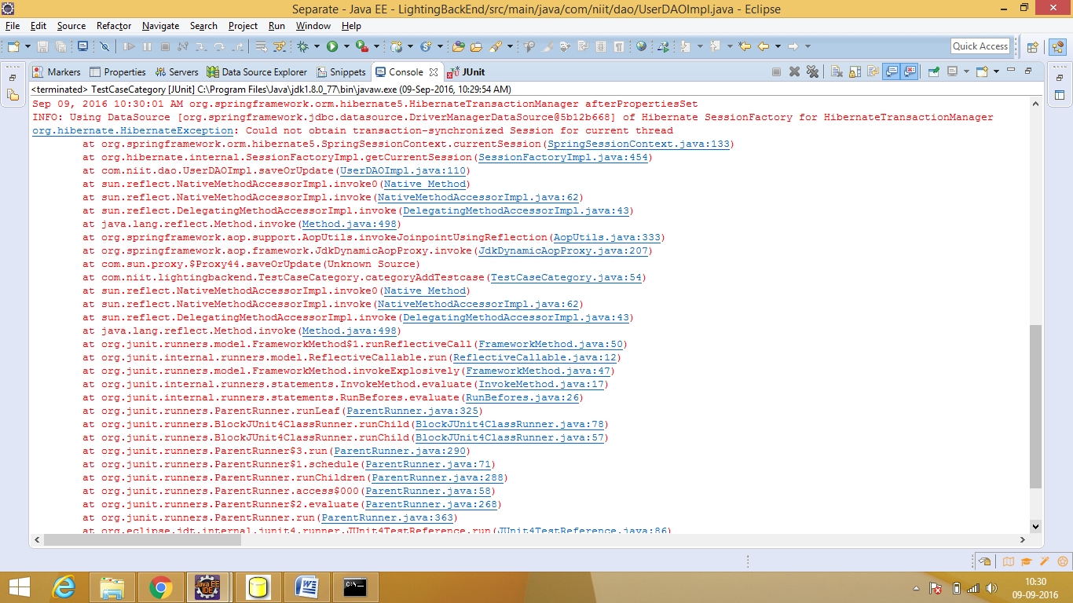

@transactional was missing

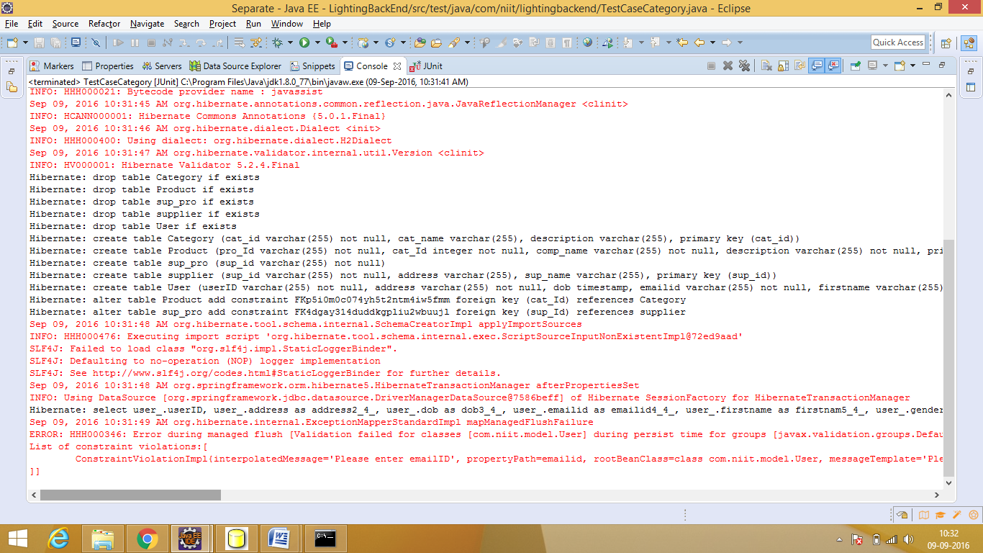

Required field was left blank

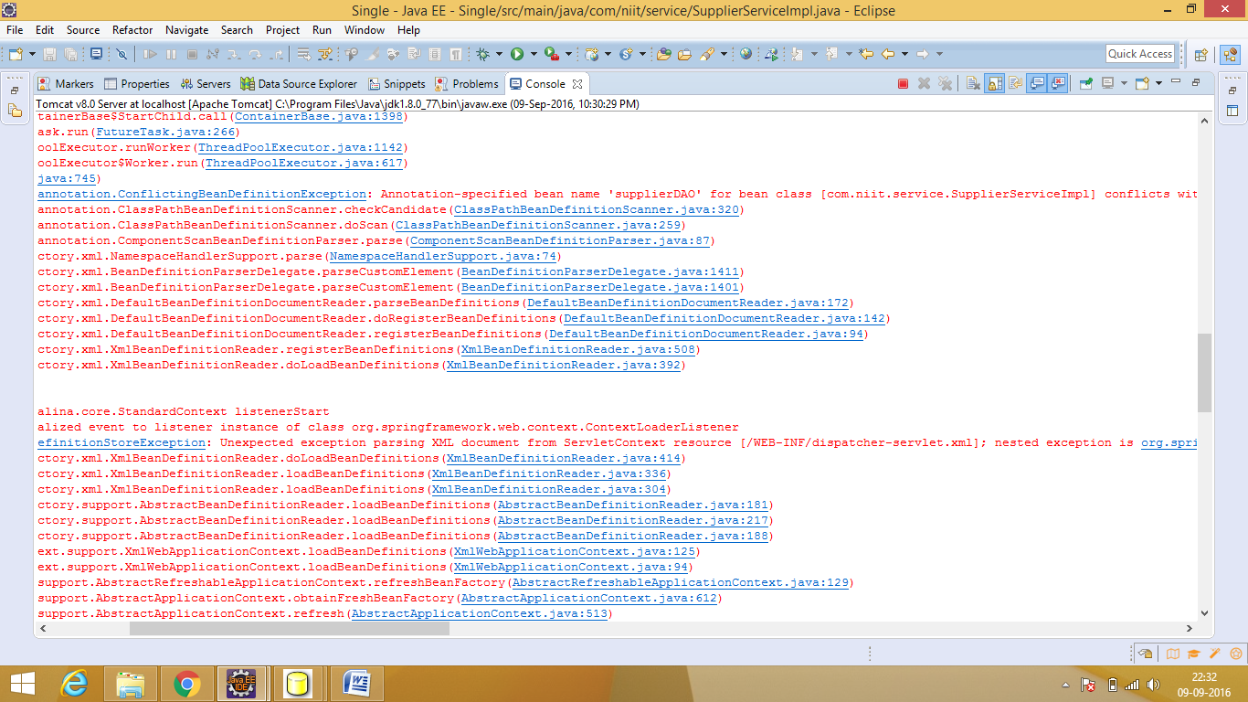

@supplierDAO repository was created in both service and DAOImpl